Name: Laiba Mudassar
Roll No: SP26-BCS-021
Course: programming fundamentals
Assignment: Assignment LAB 1
Submitted To: Sir MUDASSAR
COMSATS University Islamabad

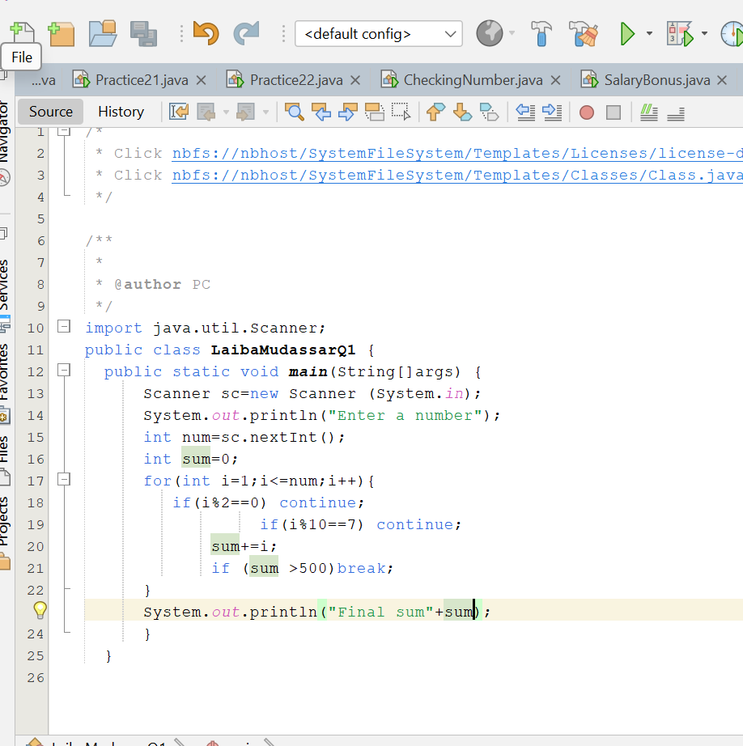
QUESTION 1 SUM OF ODD NUMBERS

OUTPUT
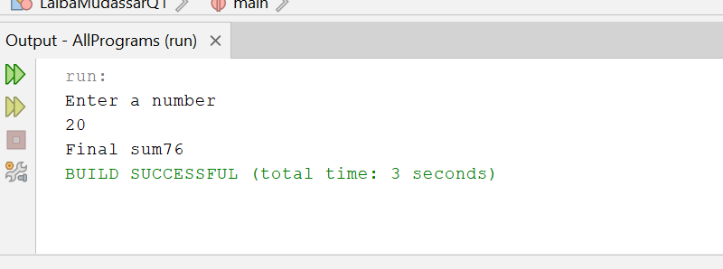
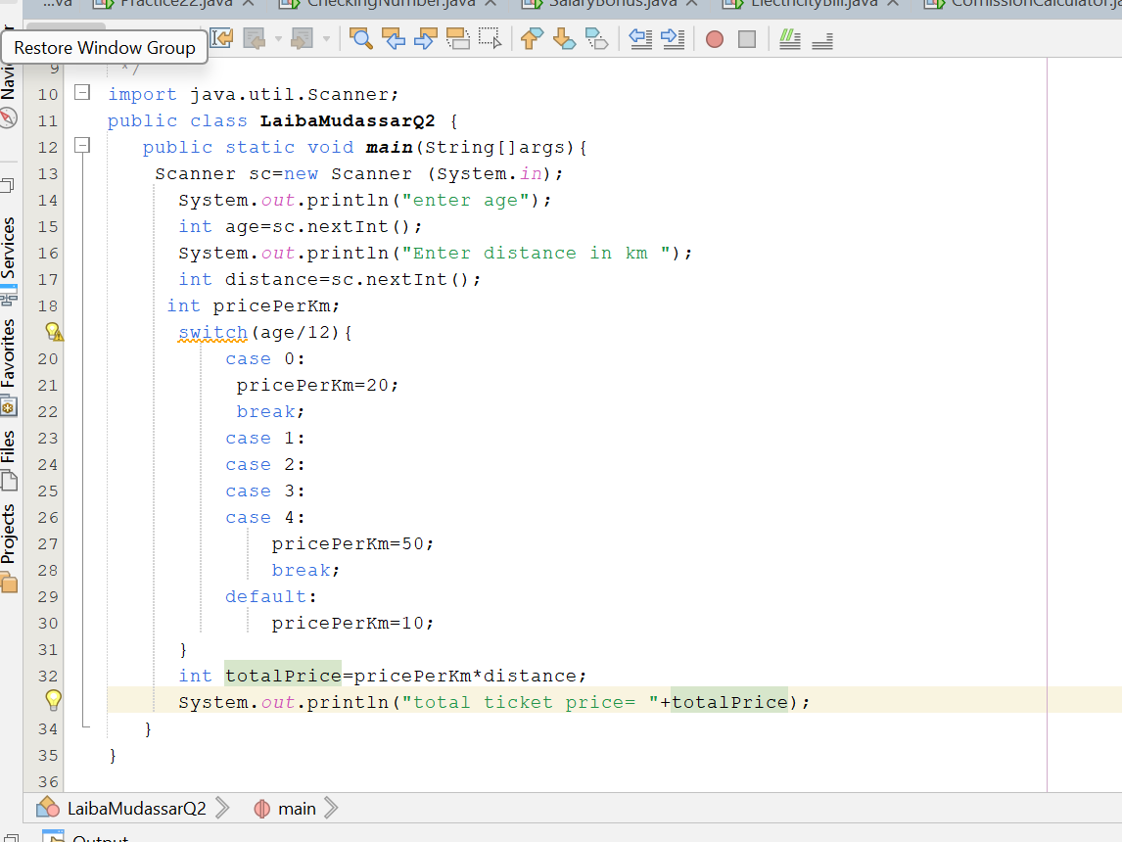
QUESTION NO 2 TRAIN TICKET PRICE

OUTPUT

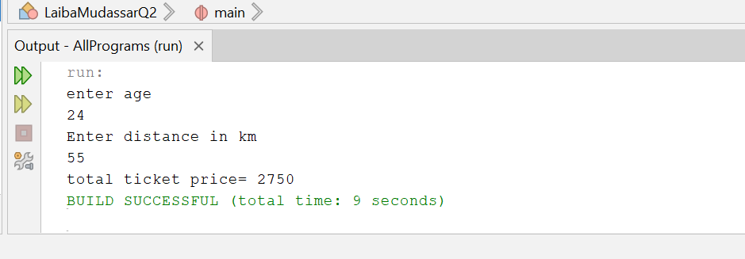

QUESTION NO 3 ZAKAT CALCULATOR

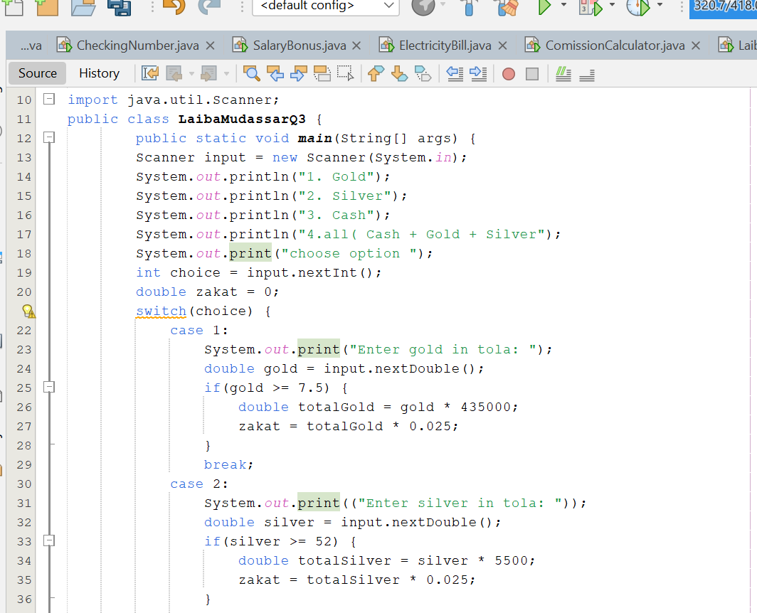
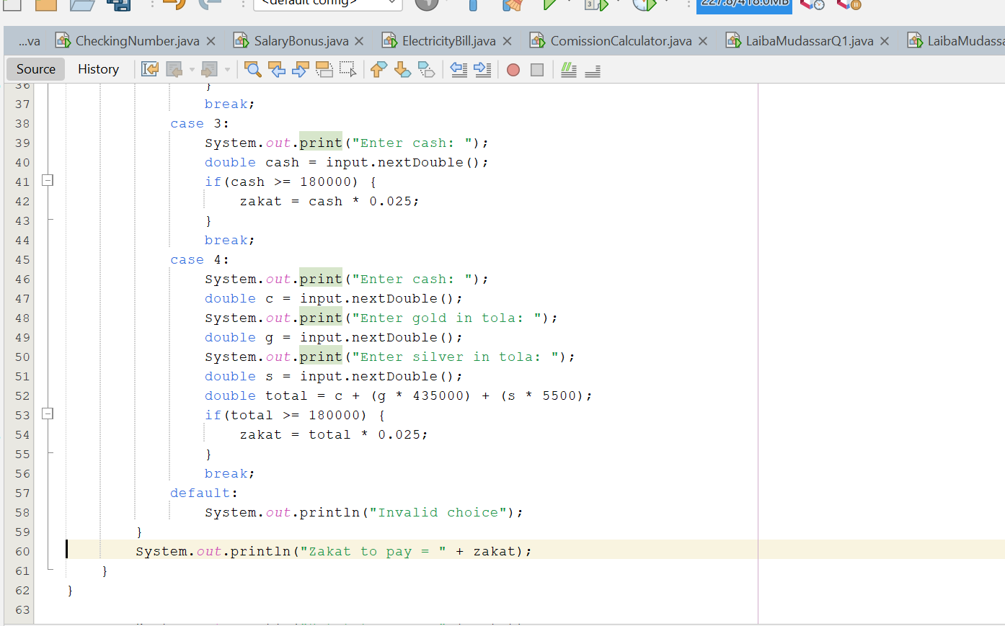
OUTPUT
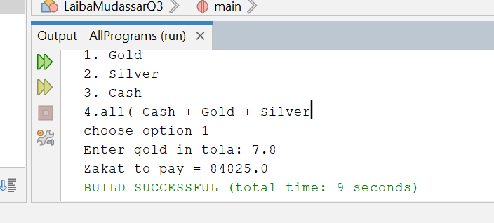

QUESTION NO 4 NUMBER GUEESING
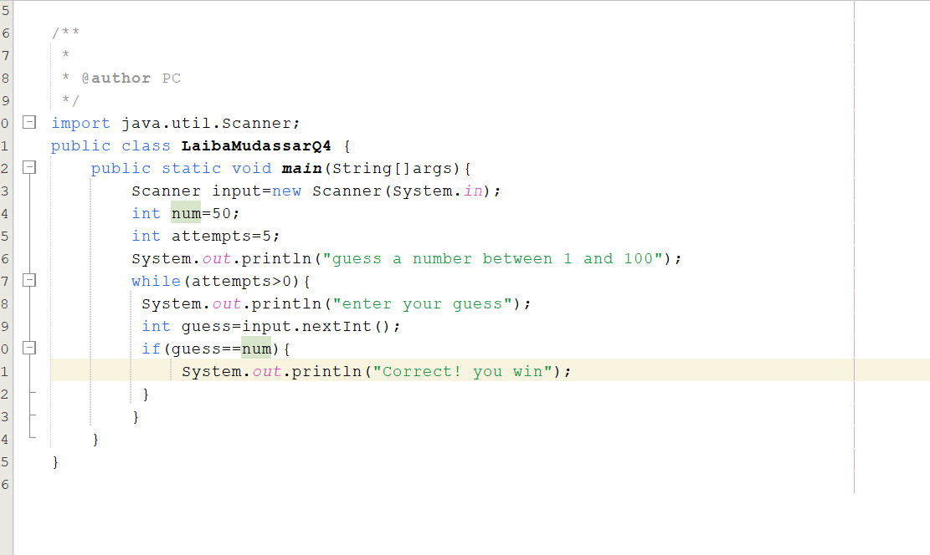

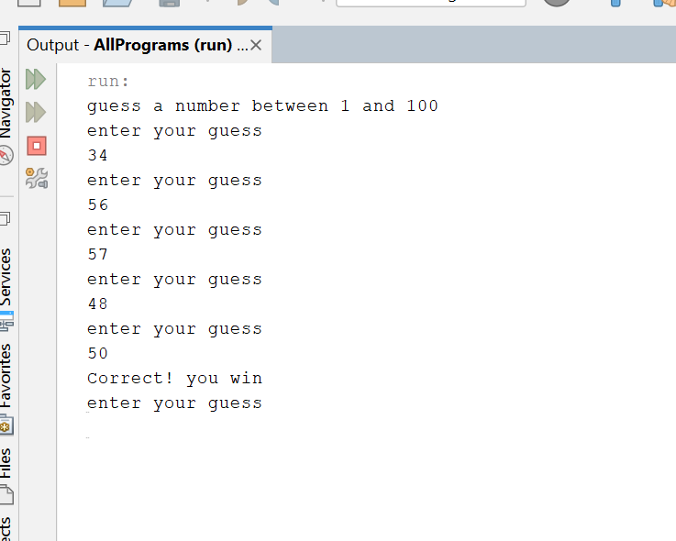
OUTPUT

QUSTION NO 5 PANLINDROME NUMBER
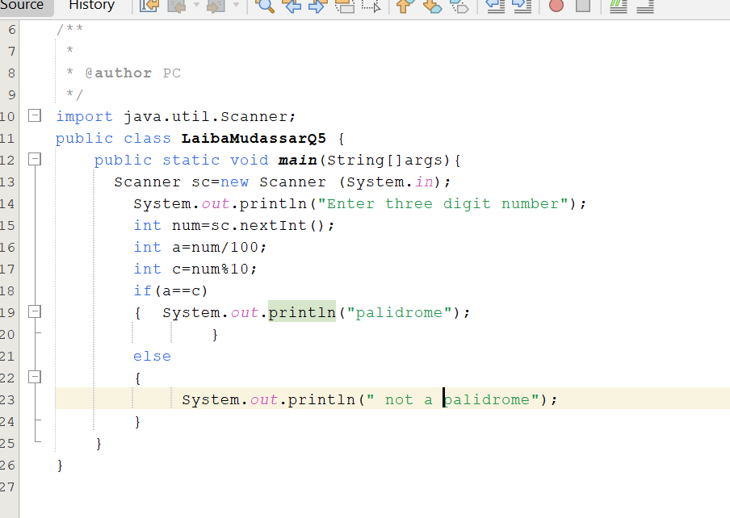
OUTPUT

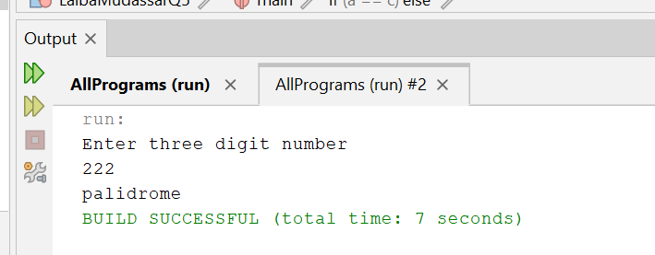

QUESTION NO 6 COUNT POSITIVE NEGATIVR AVERAGE

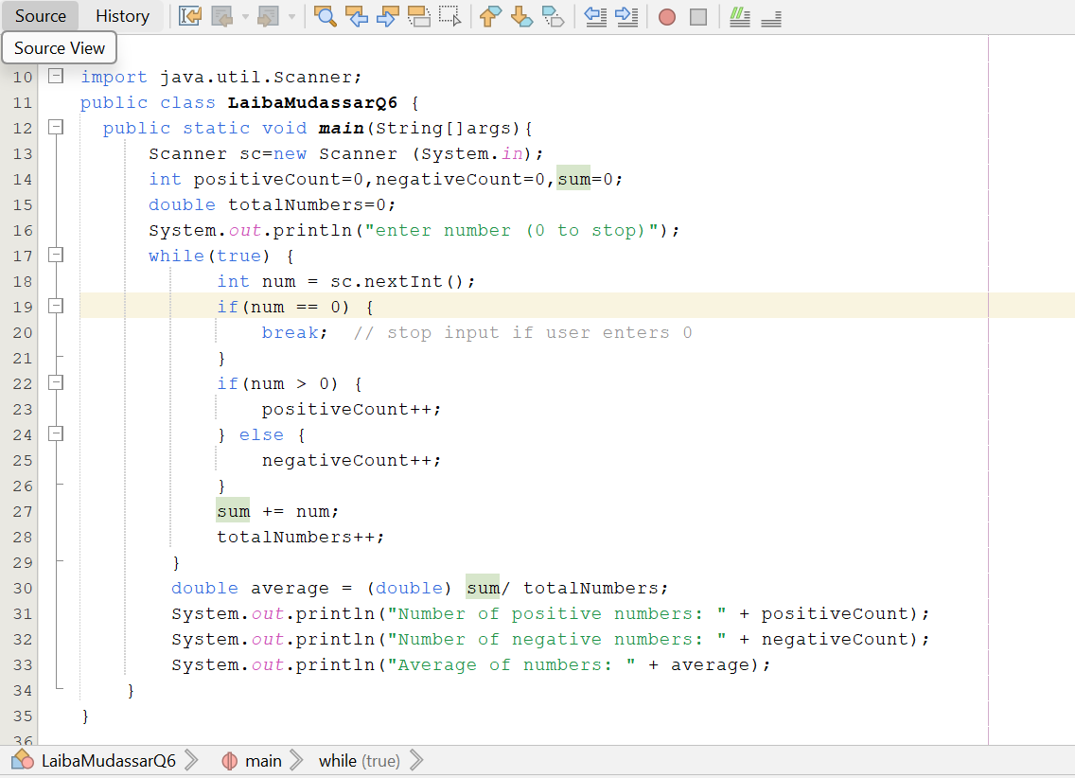

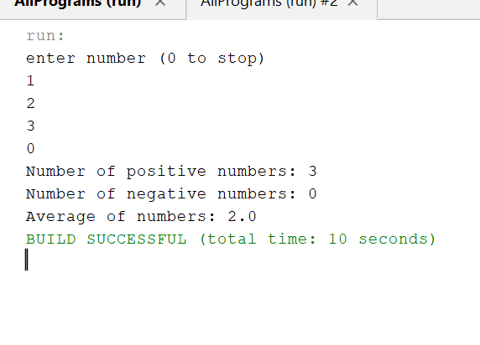
OUTPUT
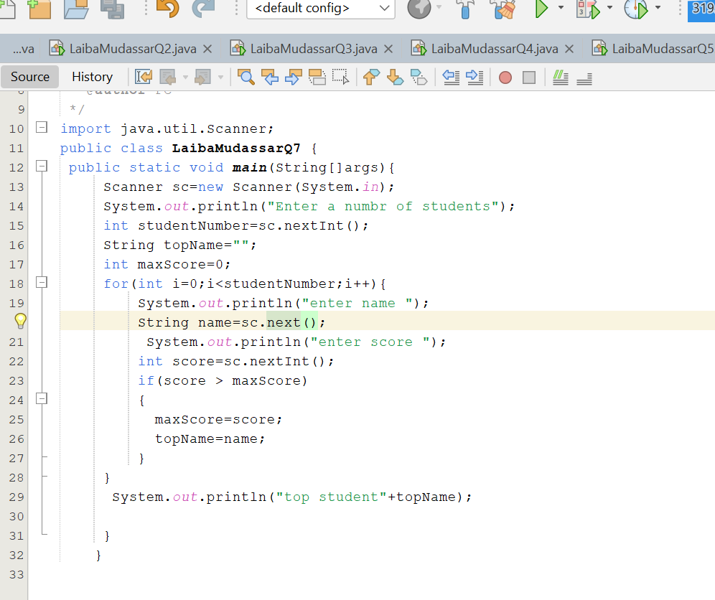
QUESTION NO 7 HIGHEST SCORE
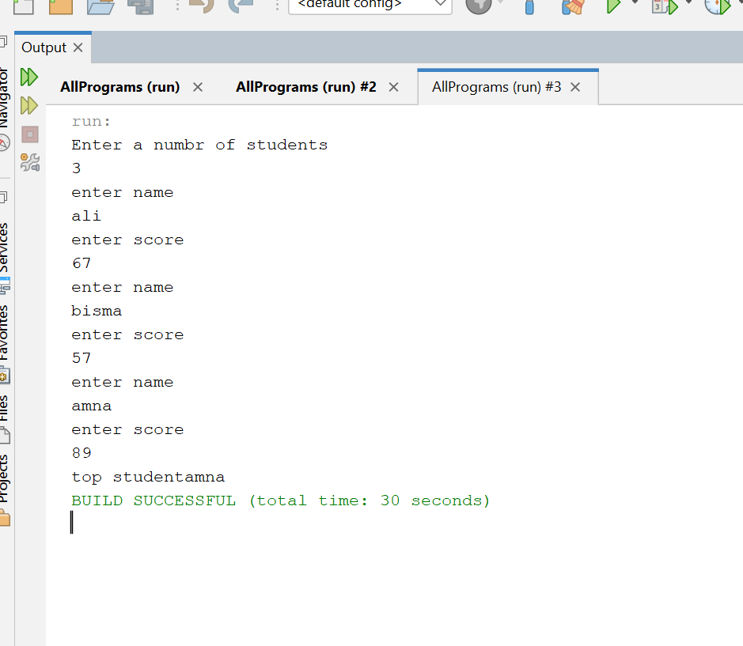
OUTPUT

